Preface

This Guide explains how to use Trade Innovation’s SLA functionality during transaction processing. It assumes that you are familiar with standard Trade Innovation processing described in the Common Facilities User Guide – Trade Innovation and the associated product-specific user guides.

# Introduction

This chapter explains how Trade Innovation handles service level agreements. It provides an overview of the Dashboard window used for monitoring the work assigned to teams and details of service level agreement processing. It also explains how it relates to Trade Innovation’s standard transaction processing functionality.

It also introduces the terminology used in this guide.

## Service Level Agreements and Trade Innovation

Trade Innovation’s service level agreement (SLA) functionality allows your bank to set up SLAs with customers involving target times for completing time-sensitive events. The Dashboard is then used during transaction processing to monitor work in progress in each team and manage workflow so that those target times are met.

Where users have access across multiple zones, where logging on under a default team, the dashboard is used to show the work in progress ‘to do‘ list for items across those zones.

Your bank first sets up one or more SLAs, allocating customers to them either individually or by customer group or customer type.

It then sets up target times for completing events covered by an SLA.

During transaction processing, events are displayed as having one of three SLA statuses - low, medium or high - depending on how close to their target completion time they are. Your bank defines when an event’s status will change to medium and then to high, relative to its target completion time.

Each of the three statuses has its own colour code .This visual colour coding allows you to see at a glance which events are the most urgent.

With Trade Innovation’s SLA functionality implemented, your bank is able to group users into teams. Each user can be a member of one or more teams, and these teams can have a flat or a hierarchical structure. Your bank determines which team an event will be routed to at each point in its life-cycle.

As a Trade Innovation user, you will have normally been allocated a default team so that when you log on to the Dashboard, you are shown the events awaiting completion for your default team. You can switch from your default team to any other team you are assigned to. Users assigned to a team in a hierarchy can also switch to teams lower in the hierarchy. If you do not have a default team then you can select a team from the teams to which you belong. Your team is used as the default value for the Responsible Team field on transactions entered by you.

Each team has a standard set of working profiles set up for it by your bank, and you can load these as required.

The Dashboard shows information relating to the work of the team or teams to which you belong, allowing you to choose which one to work in, depending on which team has the heaviest or most urgent workload. If you have the appropriate security permissions, you can allocate transactions to another team or user.

## Displaying the Dashboard

You must have the security capability ‘ViewDashboard’ assigned, to display the dashboard.

When you log on to Trade Innovation’s transaction processing application the system logs you on using the default team set up for you, and the Dashboard window is displayed, listing transactions with work in progress for that team.

If the system cannot identify a default team, it displays the Dashboard with no details, a team must be selected to show totals.

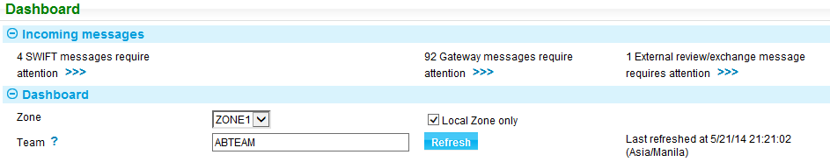

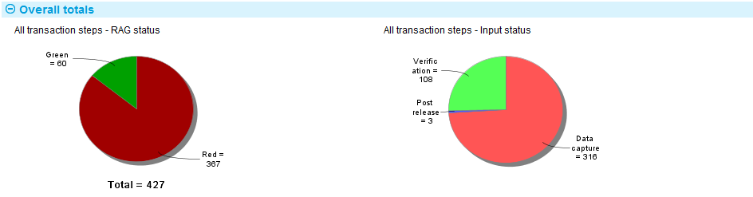

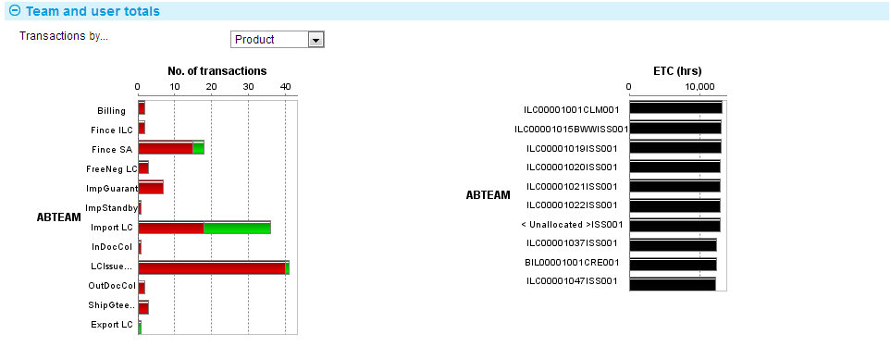

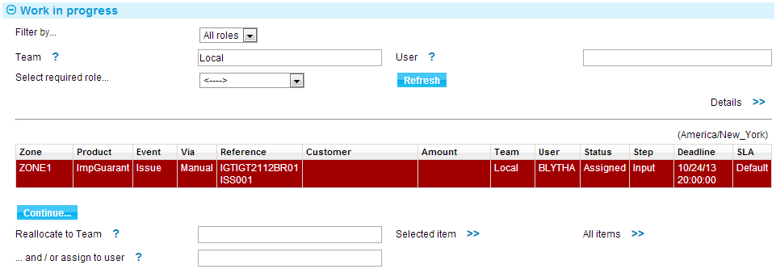

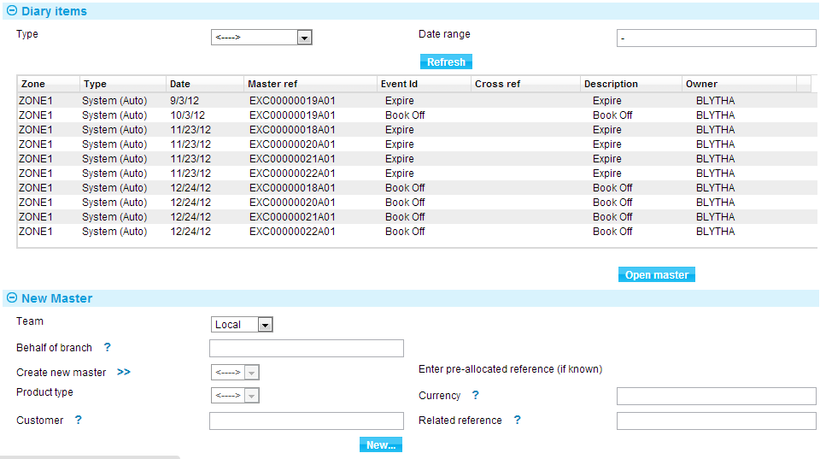

The Dashboard graphics show the overall totals for the team covering the following information:

* Total number of transactions with active steps assigned to your team and sub-teams according to:
* SLA status - Low, Medium, High
* Input status – shows the number of event transaction event steps at each phase of the event’s step lifecycle. The phases are:
* Data capture
* Verification
* Release
* Post release

followed by Team and User Totals showing the following:

* All the teams to which you belong in the next level down in the team hierarchy and a count of the number of transactions in those teams by different categories
* Information on transactions assigned to you as an individual user
* The individual transactions in the different teams and when they are due to complete. Transactions in the order in which they are due to complete, according to the target completion times provided by the SLAs used, and the colour of the background indicate their SLA status. (Overdue items are shown in black.)

These graphical displays are described in detail in Chapter 6.

The Work In Progress section shows the Trade Innovation transactions associated with the teams to which you belong which are in progress and that your user role allows you to continue to the next step or to completion and release. These are processed in the usual way once you have opened them. When you complete work on a transaction and close it, the details in the Work in Progress pane are updated automatically and the rest of the information in the Dashboard is refreshed.

If external system data is provided through a proxy zone, data from the proxy zone can be fed into this pane and the Diary items pane. Your system can also be configured such that selecting an individual work in progress or diary item transaction from the proxy zone passes transaction data to request transfer directly to the transaction data in the external application.

See the *SDK Systems Integration Guide* – Trade Innovation for instructions on navigation and setting up proxy zones.

A link on the Dashboard window allows you to close the Dashboard window and work within the Masters browser. This gives you access to all transactions (not just those events in progress) within the current zone. A corresponding link on the Masters browser allows you to switch back to working from within the Dashboard A link on the Dashboard window allows you to close the Dashboard window and work within the Masters browser. This gives you access to all transactions (not just those events in progress) within the current zone. A corresponding link on the Masters browser allows you to switch back to working from within the Dashboard window.

1. Care should be taken when allowing access to both the Dashboard and the Master browser. The Master browser presents information per zone. The Dashboard can access items across zones. After accessing a Dashboard item in another zone, the user will have been transferred to that zone and therefore will see that zone’s details in the Master browser. Users should be restricted from the security capability ViewMasterBrowser where necessary.

You can see what zone you are in at any time by looking at the title banner in the Trade Innovation session:

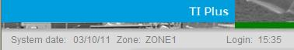

When you are working in the Dashboard across multiple zones, the Local Zone flag is available to restrict the work in progress details to only the current zone. This is further described in Chapter 4.

## Before You Begin

The following is a list of things your bank will need to consider before implementing Trade Innovation’s SLA functionality.

Before your bank begins to use the SLA functionality it needs to consider the following:

* The Dashboard is used cross-zone where multiple zones are implemented. It is not recommended to have both test and live zones in the same global application if test zones are implemented. If this is necessary, ensure that the user IDs used in the test environment differ from the live.
* The cross-zone Dashboard is for managing work in progress. Call centre ‘enquiry’ based users should not require it.
* The types of SLA your bank will offer.
* What events will be covered by each SLA.
* For each event covered by an SLA, the average time taken to process the event at each step in its life-cycle and the overall average time taken to complete the event.
* For each event covered by an SLA, whether it will have a Final Print step.
* For events not covered by an SLA, the average time to complete each of the steps in an event’s life-cycle, and the overall average time taken to complete such events. These average times are across all events not covered by SLA processing.
* For each event for each separate SLA, the target time to be provided for completion of the event, and the points at which the status of the transaction will change status to medium, and then to high.
* For each event covered by an SLA, the event’s initial step when created manually and when created from an incoming electronic message.
* The teams the bank will use, how will they be structured, and which users will be allocated to which teams and which branches will be included for processing by the teams.
* The SLA-related capabilities to be assigned to each user role.
* The standard working profiles needed for each team and/or user.
* Which team should an event be allocated to at each step in its life-cycle, and based on what criteria.
* Which customers and/or customer groups will have SLAs, and whether those SLAs will be specific to a customer or customer group.

The following is a list of things your bank must do prior to implementing the SLA dashboard for transaction processing:

* Use Trade Innovation’s security application to set team and users’ roles so that they can work with SLA-related functionality
* Decide which users will have a supervisory capability
* Set up the target times for each event covered by an SLA
* Set up the average times for events not covered by an SLA
* Set up the SLAs and allocate customers to them
* Set up teams and allocate users and branches to them

Review event step settings, adding a Final Print step where required and defining which teams each event is to be routed to at each step.

# The Dashboard Window

This chapter describes the Dashboard window and provides an overview of the functionality it provides. This functionality is described in full in subsequent chapters.

## Subsections of the Dashboard

The dashboard window is divided into the following panes:

* The Incoming Messages pane, which provides information on the number of electronic messages requiring attention
* The Dashboard pane (see page 6)
* The Overall Totals pane (see page 7)
* The Team and User Totals pane (see page 7)
* The Work In Progress pane (see page 8)
* The New Master pane, which allows you to initiate a new transaction, as described in the Common Facilities User Guide – Trade Innovation
* The Diary Items pane (see page 12)

The left side of the dashboard window has links that allow you to:

* Access functionality used to set up and load working profiles, as described in Chapter 4
* Configure the data used to control the graphical displays in the Dashboard window, as described in Chapter 3
* Close the Dashboard window and switch to the Masters browser

### The Dashboard Pane



The Dashboard pane indicates the team in which you are currently working.

Your bank may have set up a default team for you, and this is the one displayed here whenever you log on. You can select or change to any other team to which you belong. Press Refresh to effect the change of team.

The Refresh button results in updates to the entire Dashboard window. The system displays the time you last updated the display in the Dashboard pane according to the user’s time zone.

The dashboard window is also updated whenever you change your working profile.

### The Overall Totals Pane



1. The graphs in this pane are displayed only if you have the required security capability ViewSLACharts. The colours used are bank-definable (using the style_ti_plus2.css file).

The Overall Totals pane shows information in graphical format on the workload for your current team across all zones.

The first pie chart shows how many active transaction steps are allocated to your current team and sub-teams, and how many of them there are at high (Red) status, at medium (Amber) status and at low (Green) status.

The second pie chart shows the number of active transaction steps at each phase of the event’s step lifecycle.

The Overall Totals pane is described in full in Chapter 6.

### The Team and User Totals Pane

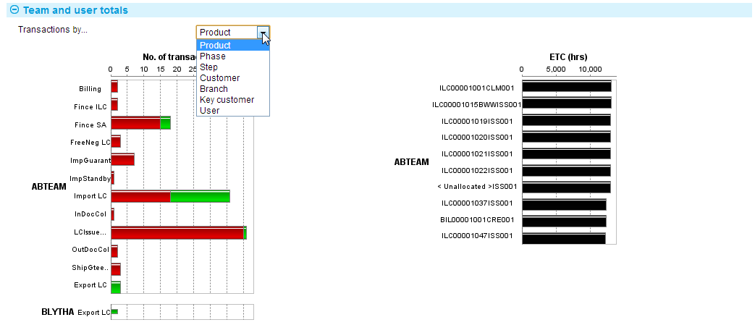

The Team and User Totals pane uses two different displays to show information about the workloads allocated to the team you are currently using, and any sub-teams.

The No of Transactions charts show the number of transaction steps allocated to each team, by product.

The ETC (estimated time to completion) charts show the statuses of the most urgent transactions for each team due to complete in the period in question.

The Team and User Totals pane is described in full in Chapter 6.

### The Work In Progress Pane

The Work In Progress pane lists all the event steps that are in progress in order of target completion time. These are the transaction steps that have not yet been completed. Filter fields allow you to control which transactions are displayed.

For a normal user filtering can be done either by role – ‘My roles’

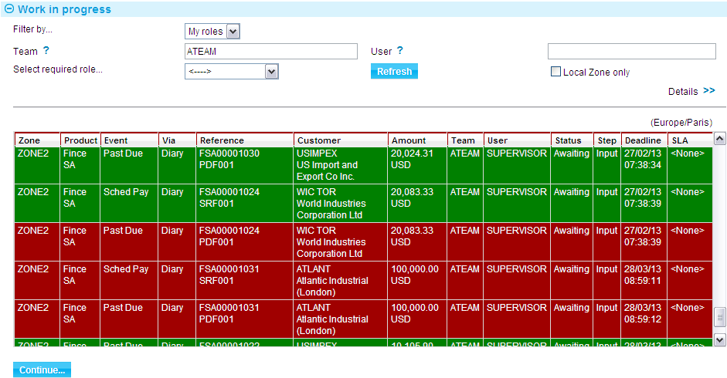

or by profile.

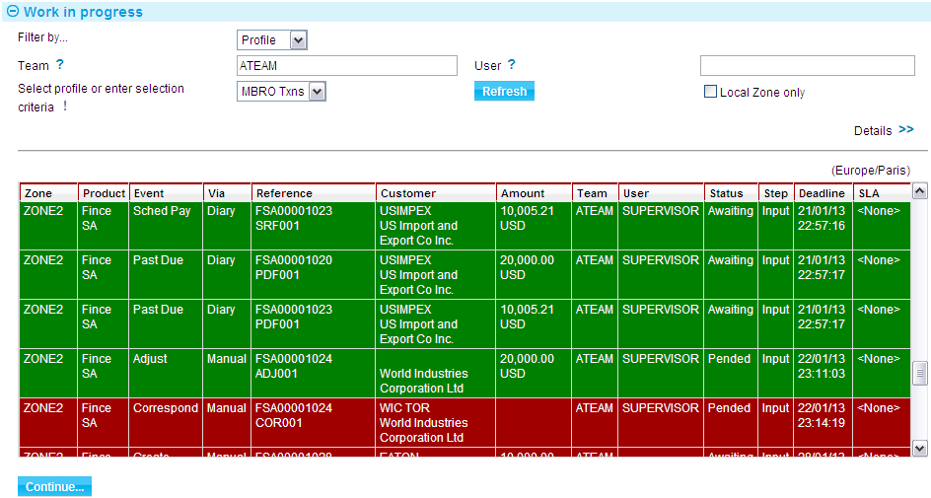

The Work in Progress pane lists outstanding transaction details, in order of target completion time. Filter fields allow you to control which transaction details are displayed.

Transactions are displayed by event for active steps, and the colour used indicates a transaction event’s SLA status - high, medium or low. You can open a transaction from within the Work In Progress pane in the usual way by highlighting it and pressing the Continue button. The roles assigned to you will determine if you can view or continue the event. When you complete work on a transaction and close it, the details in the Work in Progress pane are updated automatically and the rest of the information in the Dashboard is refreshed.

For more on the Work in Progress see Chapter 4 (see page 16).

You can also allocate work to other teams and users, if your security settings permit this as described in Chapter 5 (see page 21).

Depending on the roles assigned the user will be able to view or continue the event.

For a supervisor user filtering can also be made for ‘All roles’ in teams that the user belongs to in addition to ‘My roles’.

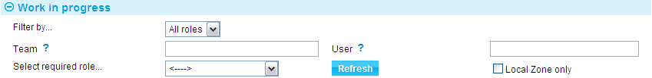

### Finding and Displaying Transactions in Work in Progress

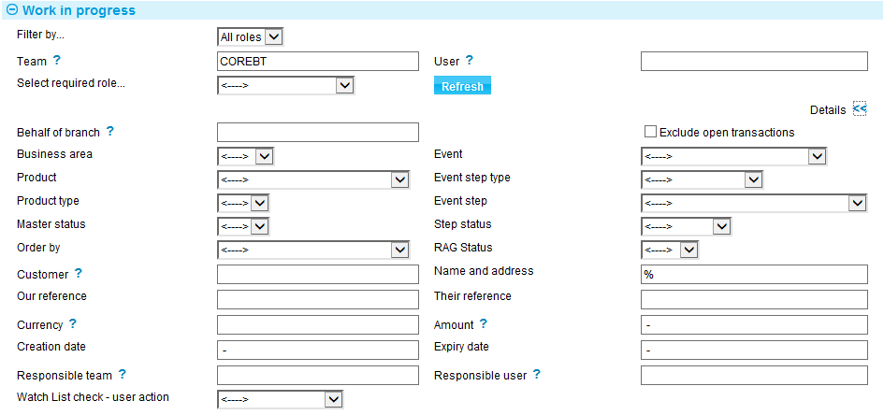

The fields in the Dashboard filters within the work in progress pane permit you to limit the display of master records to those matching various criteria. Your currently loaded working profile provides default values for the filter fields. When you first open the Dashboard, the system automatically loads the working profile you last used.

Also, when browsing during transaction processing, your team(s) are used to determine the branches and main banking entity within which you can work.

1. When searching in the Dashboard, selecting Customer  will allow you to choose a specific source banking entity and customer where your team(s) cover multiple sources. Alternatively, entering a full or partial customer mnemonic directly into the field results in those details being used as a general filter allowing all transactions for that customer across all sources to be displayed.

For the Our Reference and Their Reference filter fields, similarly use of wildcard characters to search for a reference across zones. The dashboard filters work as follows:

|  |  |
| --- | --- |
| The all-characters wildcard % | %ABC% will find anything that has ABC at the beginning, in the middle, at the end or an exact match.  ABC% will find anything with ABC at the beginning.  %ABC will find anything with ABC at the end. |
| The single-character wildcard * | A*C will find all three character details starting with A and ending in C.  *BC will find all three character details ending with BC.  AB* will find all three character details starting with AB. |
| Combinations | Where ILC and ELC are used as the respective prefixes *LC% will find all import and export letters of credit. |

Note also that Trade Innovation uses a method of fuzzy matching for searches on transaction reference fields in this window to help compensate for typing or transcription errors (for example, typing 'B' instead of '8' or 'S' instead of '5'). Consequently the system may find more than one match, even though you have typed in the exact reference for a transaction accurately.

Additional filters are available from the details >>.

The following table lists the filter fields in the Dashboard window and explains how to use them to set criteria. Press Refresh when you have completed setting the filter criteria:

| Field | What it Determines |
| --- | --- |
| Team | Shows events belonging to a particular team, or for all teams. You can only select a team other than your own if you are assigned to that team. |
| User | Shows events belonging to a particular user. |
| Behalf of Branch | The behalf of branch for the transaction as entered by the user or set from the incoming SWIFT or gateway message. The behalf of branch determines the parameter sets that are to be used to generate charges, documents, postings, etc. during transaction processing. The branch can be changed to any other branch within the same main banking entity that shares the same parameter sets. |
| Exclude Open Transactions | Only shows transactions which are not currently being worked on by another user. |
| Responsible Team | Shows transactions where the master is associated with a particular team, or for all teams. |
| Assigned Team | Shows transactions where the event is associated with a particular team, or for all teams. |
| Responsible User | Shows transactions where the master is associated with a particular user. |
| Business Area | Shows transactions associated with the business area that includes the product(s) you wish to work with. |
| Product | Shows transactions for all products or for a particular product only. If you have specified a business area in the Business Area field, then the product field will include products in that business area only. |
| Product Type | Used if you have selected a value in the Product field, to show transactions for all product types within the selected product, or for a particular product type only. If you have not selected a value in the Product field, this field is not available. |
| Event | Shows transactions of that particular event. You cannot specify an event unless you have specified a product. |
| Event step type | This filter allows all steps of a selected type to be shown. For example all log steps. |
| Event Step | This filter allows any of the actual step descriptions mapped by your bank to be selected. |
| Master Status | Shows transactions associated with a master of a specific status, or all master records. |
| Step Status | Shows transactions with a specific status. |
| RAG Status | Shows transactions with a high (Red), medium (Amber) or low (Green) status. |
| Customer | Shows transactions for one customer only, or for all customers. If you specify a customer, the system matches that customer against either the principal party or the other party in the master record. |
| Name and address | Shows transactions matching the text within the customer name and address. The system matches the address against either the principal party or the other party in the master record. |
| Our Reference | Shows transactions matching a part of or full bank’s reference. |
| Their Reference | Shows transactions matching a part of or full other party’s reference. |
| Currency | Shows transactions using a particular currency, or all currencies. |
| Amount | Shows transactions with amounts within a certain range. Enter values to define the range either side of the hyphen. |
| Creation date | Specify a date either side of the hyphen limits the display to master records or events started on or between the two dates entered. Enter a start date, followed by a hyphen, to display all master records started on and since a particular date. Enter a space, followed by a hyphen and a date, to list all master records started up to and including that date.  You can enter partial dates, such as '28/02-03/03' instead of 28/02/2000-03/03/2000'. In such cases, where the end date is later than the start date, the system assumes that they are both in the current year. If the end date is later than the start date, the system assumes that the start date is in the current year and the end date is in the next calendar year. |
| Expiry date | Specify in the same way as the creation date field to limit the display according to a master record's expiry date. |
| Order by | Order the list by one of the following options:   * Customer * Product * Reference (our or their) * Master creation date (old to new or new to old) |
| Watch List Check - User Action | Limits the display to events with the selected watch list checking user action. See the Common Facilities User Guide – Trade Innovation for a list of values. |

### The Diary Items Pane

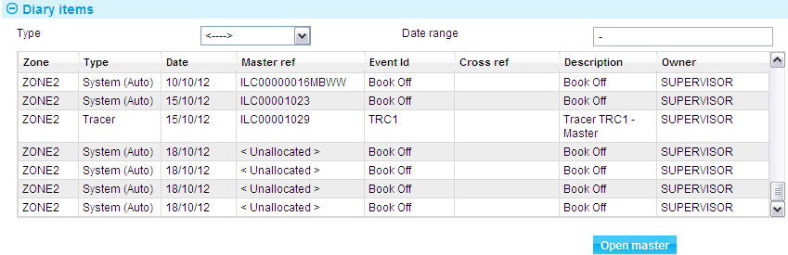

The Diary Items pane displays a list of diary actions that are either outstanding or fall due today, with owners belonging to the team selected in the Dashboard pane. The actions shown are for all products, regardless of the working profile loaded.

A date range can be selected or a relative range where diary items have different processing dates under separate processing cycles.

By default, all types of diary action are shown. You can use the Type field to limit the display to actions of a particular type:

|  |  |
| --- | --- |
| Manual | Actions entered manually, such as a reminder to make a telephone call. |
| System (Auto) | Actions that will automatically generate an event, such as Book off or Expiry, during overnight processing on the required date. |
| System (Manual) | Actions that will generate an event, such as Book off or Expiry, but which require manual intervention for that event to be generated.  The diary action is generated during overnight processing when it falls due, but no associated event is created. For example, if the action is to book off the transaction, a book-off action will be created in the diary, but no Book off event will be created.  You must create the event manually using the Create New Event drop-down field in the Master Summary window. Once you have created the event you can flag the diary action as 'actioned'. |
| Tracer | Tracers. |

Information shown for each diary item includes:

* The type of action
* The date the action is due to be performed
* The reference of the relevant master record
* If the action involves the generation of an event, the event's reference
* Any cross-reference, for example to another event
* An description what the action involves , for example, tracer description
* The user to which the action is assigned

Diary items are listed under one of two headings:

|  |  |
| --- | --- |
| **Scheduled** | This includes all actions scheduled to happen today or at a future date. |
| **Unactioned** | This includes all actions that should have been performed by the current processing date, but have not been. These will consist of manual actions that have not been marked as actioned; and automatic actions that Trade Innovation’s batch processing has been unable to complete. If there are no such unactioned entries in the diary, then this heading will be omitted. |

To open the relevant transaction select the diary action, then click on the Open Master button.

See the Common Facilities User Guide – Trade Innovation for more on the diary facility, including instructions on actioning a diary item.

### Customer Filters

When browsing for customers during transaction processing, the behalf of branch determines the source banking business of customer details. However, when working on the Dashboard, you will be able to work across several banking businesses.

When entering the Customer mnemonic directly in the dashboard, all Masters and events matching that Customer across all banking entities will be displayed. Selecting a specific source banking business and customer using the customer browser will restrict the search to that specific customer.

# Configuring the Dashboard Display

This chapter explains how to set the parameters used to control what data is used in the Dashboard window’s graphical displays.

## Configuring the Number of Items for ETC Chart

Selecting the Dashboard Profile link from the left side of the Dashboard window displays a window that allows you to change the parameters used to control the number of items to be shown in the ETC chart. This simply limits the chart to show only the next 'n' items for each team.

This change only applies to the data being displayed for you; it does not affect other Trade Innovation SLA dashboard users see. The settings remain the same if you change team.



The Number of Transactions to Display field controls how many transactions are used in the ETC charts in the Team and User Totals pane. Where the team has more transaction outstanding than the number entered here, the system displays those due to complete soonest.

# My Roles, Team Roles and Working Profiles

This chapter covers roles, team roles and working profiles.

## Roles and the Dashboard

When you log on to the dashboard, Trade Innovation automatically loads the roles you are assigned to for all your teams and displays the filter by... as ‘My roles’.

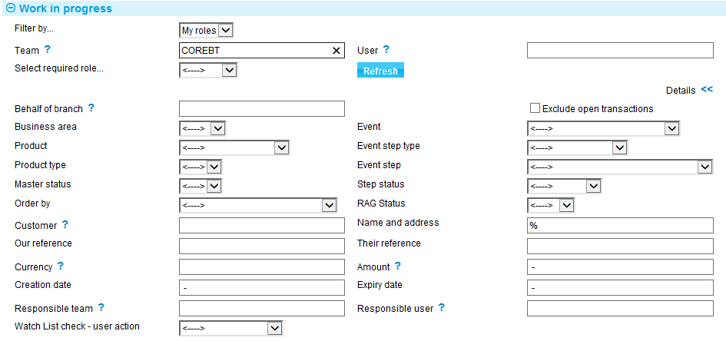

This allows you to see all outstanding work for your roles across all the teams you belong to and allows you to continue any outstanding transaction. You can enter a specific team to see the work outstanding for you in that team or enter a specific role. If you change team, then it loads the roles for the new team. The Work in Progress window displays all outstanding work that matches your roles and team.

1. The number of items presented in the work in progress list is restricted according to the system option MasterBrowserRowLimit. A warning is presented if this is exceeded. The highest priority items from all zones are always shown first.

When you select a work in progress event, it is opened in the appropriate mode for your role. For example:

* You may have no roles assigned within the team currently assigned to the event so you can only View the event
* You may have a role that allows you to Authorise but the event is currently at the Input step so you can only View the event
* You may have a role that allows you to Input and the event is currently at the Input step so you can fully carry out the input stage of the event

When your team is authorised to work across zones, you can either work within the current zone in the Dashboard by ticking the Local Zone flag, or alternately work freely through the list in priority order.

When using the Dashboard cross-zone, your session will pass to the zone of the current work in progress item. Accessing the Master browser will show all transactions for the current zone. The current zone is shown in the title banner located in the top left-hand corner of the screen.

1. The security capability ViewMasterBrowser must be enabled to allow users to access transactions from the Master browser.

### Dashboard Use for Normal User

As a normal user you can choose to filter either using My roles or Profile.

You can also use the filters to refine the list of transactions displayed by adding further filter criteria.

If you filter by profile this allows you to select profiles defined for the team that represent pre-defined filter selections.

### Dashboard Use for Supervisor User

If you are a supervisor, the system allows you to choose between My roles, All roles or Profile. All roles allows a supervisor to see outstanding work for all roles in the team. This enables you to monitor the workloads across teams and users and to reallocate work if required to balance the workloads.

## Working Profiles and the Dashboard

You can use working profiles to control what transactions are displayed in the Work In Progress pane.

When you switch to Filter by... Profile, the system automatically loads the default working profile for your default team. If you change team, then it loads the default working profile for the new team.

Your bank will have set up one or more working profiles for each of the teams (see page 16) it has set up for SLA processing. These working profiles are shared by the members of a team.

You can also set up and maintain your own working profiles, which are specific to you (see page 17). The same personal profiles are available to you regardless of your current team.

You can change your working profile at any time. You can also make temporary amendments to the working profile you currently have loaded.

## Team Profiles

The Team Profiles link in the Dashboard window allows you to change the profiles set up for a team. If you have the required security capability set you can use this link to set up new working profiles for a team, amend or delete existing ones, and change a team's default working profile.

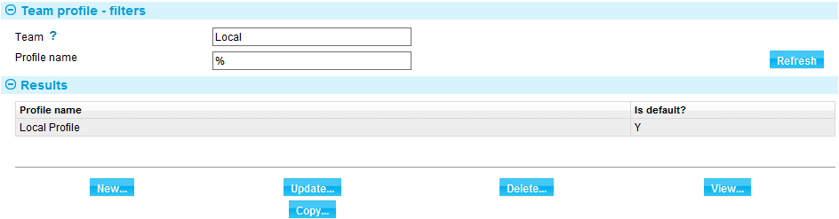

To create a new working profile, press the new button. You can also create a new profile based on existing working profile by clicking Copy.

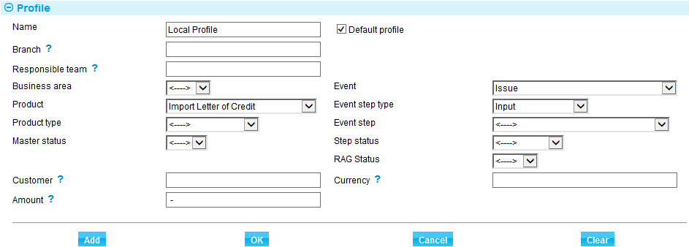

When you press the Copy button the fields change to show the values for the selected working profile. Overtype these values as required - the table at the end of this section explains what to enter into the fields in this pane (the Appendix explains how each of the filter fields is used).

To save the new working profile, press OK.

Change the values in the filter fields as required (the Appendix explains how each of the filter fields is used). Enter a name for the new working profile into the Save Profile As field, then press OK.

To amend an existing working profile, select it, then overtype the existing values. Press OK when you have finished.

To change the default working profile for a team, select the new default working profile in the Select Profile team. Then check the Default Profile For This User/Team. When you press OK to close the window, the new default working profile takes immediate effect for all users who subsequently log on to Trade Innovation.

To delete an existing working profile, select it and press Delete. The system prompts you to confirm the deletion before removing the working profile.

## Personal Profiles

The My Profiles link in the Dashboard window allows you to:

* Change your profile to another one set up for your own personal use
* Set up a new personal working profile
* Amend or delete an existing working profile

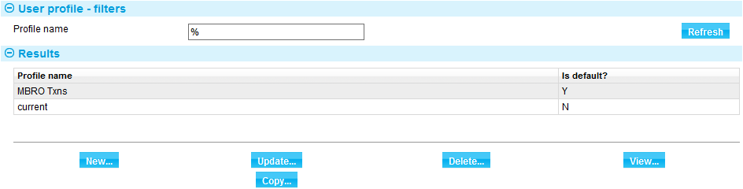

To create a new working profile, press the new button. You can also create a new profile based on existing working profile by clicking Copy.

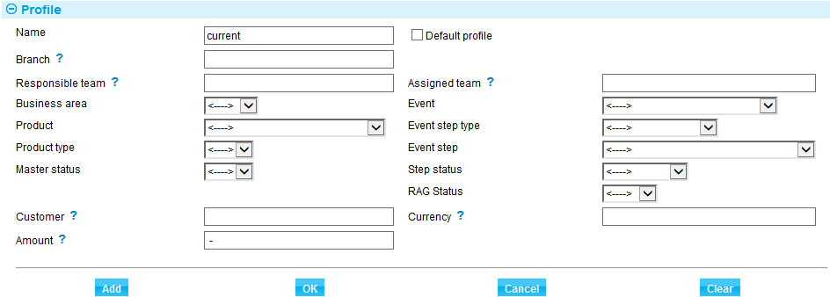

When you press the Copy button the fields change to show the values for the selected working profile. Overtype these values as required - the table at the end of this section explains what to enter into the fields in this pane (the Appendix explains how each of the filter fields is used).

To save the new working profile, press OK.

To change your working profile, select the new working profile in the Select Profile field. Press OK to close the window. The new working profile takes immediate effect on the display in the Work In Progress pane.

To amend an existing working profile, select it then overtype the existing values, and press OK when you have finished.

To delete an existing working profile, select it and press Delete. The system prompts you to confirm the deletion before removing the working profile.

You can set a personal working profile to be your default working profile by checking the Default for his User/Team field. While you are working in the Dashboard window, the team working profile flagged as the default is used as your default working profile, but if you close the Dashboard window and go into the Masters window, the personal working profile flagged as the default is used as your default working profile instead.

## Making Temporary Changes to Your Current Working Profile

Pressing the button in the Work In Progress pane displays the filter field values for the working profile you currently have loaded.

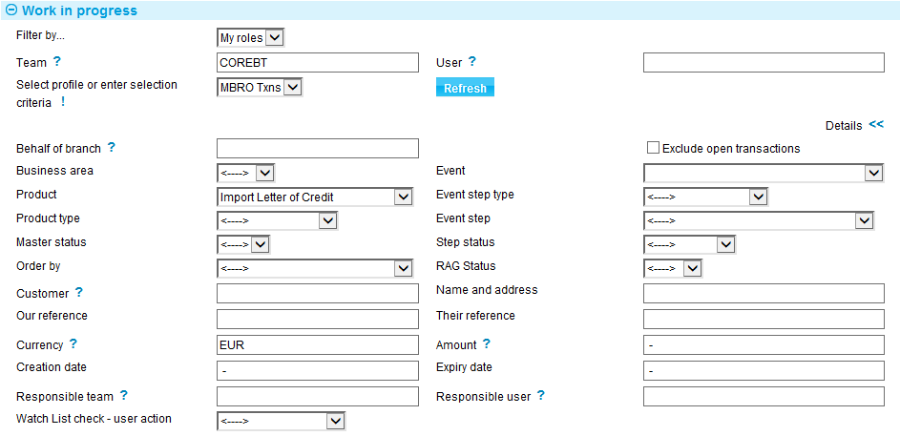

Amend the values in the filter fields as required (the Appendix explains how each of the filter fields are used) and press Refresh to apply them.

Pressing the  button hides the additional filter fields.

# Transaction Processing

This chapter covers the additional features provided during transaction processing of Trade Innovation’s dashboard.

## The Dashboard and Transaction Processing

When you log on to Trade Innovation’s transaction processing application, the system logs you on using the default team set up for you if defined, and the Dashboard window is displayed, listing transactions with work in progress for the teams to which you belong and your roles within those teams.

If the system cannot identify a default team, one must be selected from the list of those of which it is a member.

Transactions are available for enquiry or for processing which is dependent on roles assigned as described in Chapter 4.

Additionally, if you have enquiry branches assigned for the banking entities covered by your team, then this defines the scope of what transactions you can see in the work in progress i.e. branches from the enquiry branch scope downwards per banking entity covered by the team.

See Appendix B in the *Global Processing Implementation Guide* – Trade Innovation for transaction branch and enquiry branch scope examples.

Once a transaction is opened, processing continues in the usual way for that product.

This chapter covers some additional functionality affecting transaction processing when using the dashboard. This includes:

* Toggling between using the Dashboard and the Masters window as your starting point for transaction processing
* Viewing additional SLA information during transaction processing
* Completing the Final Print step
* Limits on how many transactions can be assigned to a team
* Allocating transactions to another team or user

## Toggling Between the Dashboard and the Masters Window

The Dashboard window includes a Master browser link, which you can use to close the Dashboard window and switch to the Masters window and standard functionality for viewing and opening transactions. This allows you to review completed events in addition to entering new transactions.

Your current working profile is carried over, and the system automatically sets the Event Team filter field in the Masters browser to your current team. The working profiles available to you are those set up for SLA processing.

1. That when using the Dashboard for work in progress items across multiple zones, as each work in progress item is accessed, your session changes to that zone. When the Master browser link is taken, it shows all transactions for your current session zone.

You can subsequently return to the Dashboard window using the Dashboard link from the Masters window.

See the Common Facilities User Guide – Trade Innovation for instructions on working with the Masters window.

## Allocating Transactions to Another Team or User

The fields at the bottom of the Work In Progress pane in the Dashboard window allow you to allocate one or more transactions to another team or user in that team if you as a supervisor have the ReassignTxns capability.



Highlight the transactions in the list in the Work In Progress pane, then enter (or browse for) the team and user required in the relevant field. Press the Selected Items button to allocate the selected transactions to the other team or user.

If you wish to allocate the entire workload to another team or user use the All Items button instead.

Press the Refresh button to update the Work In Progress pane after using either of these buttons.

## Additional SLA Information during Transaction Processing

When you have an event open, additional links are available to allow you to view SLA-related information.

These are:

* The Other|Service level details link, which provides details of the service level agreement being used for the transaction
* The Other|Team/User assignment link, which shows the mapping information used to route this step of the transaction to the current team

### SLA Details

The Other|Service Level details link displays a window which identifies the SLA agreement being used for this transaction, and provides details of the SLA and the related target completion times.

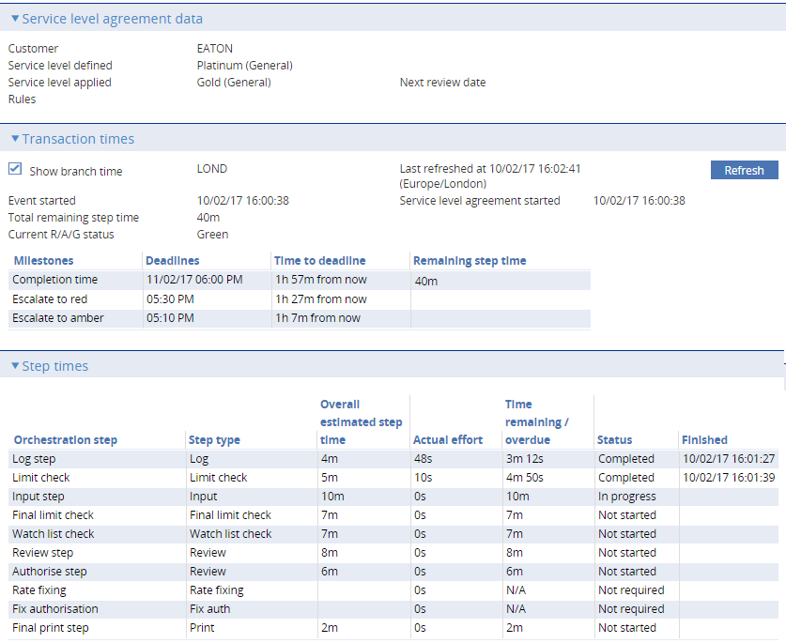

It lists all the steps in the transaction so far, and provides information on how your bank has performed against average completion times and the agreed target completion times.

Pressing the Refresh button in the Transaction Times pane updates the information shown in that pane, including the time remaining to complete the event and meet the target completion time, and the time remaining until the event’s status turns to medium and then high.

See the SDK Workflow Implementation Guide – Trade Innovation for more details on the following areas:

Remaining step times under linear and parallel orchestrations.

Resetting the SLA start time

Using SLA cutoff times

Using SLAs restricted to branch business hours

### Event Routing Information

The Other|Team/User assignment link displays a window which shows the information used to route this step of the transaction to the current team.

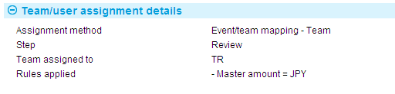

This window shows:

* Whether the event was assigned to the team manually by a Trade Innovation user or automatically by the system. The assignment can be either:
* **Manually assigned** – where the transaction was created manually or assigned from one team to another
* **Team set from originating message**– where the Team is specified on an incoming message
* **Event/team mapping** – where Event/team mappings have been used in assigning the transaction to a team. The text shown will be either
* **Event/team mapping – Team** – where the rules assign the transaction to a specific team
* **Event/team mapping – Team/User** – where the rules assign the transaction to a specific team and user
* **Event/team mapping – Last Team** - where the rules assign the transaction to the last team working on the master
* **Event/team mapping – Last Team/User** - where the rules assign the transaction to the last team/user working on the master
* **Assigned to current team / user based on step and team role** – where the current team has the necessary role to continue the event
* **Assigned to auto-allocated team based on branch and transaction** – where the transaction is assigned on a round robin basis to an auto-allocate team that is able to continue the event
* **Assigned to available team based on branch and transaction –** where the transaction is assigned to a team on a round robin basis that is able to continue the event
* **Default team for product –** where there is no team round robin
* **Gateway repair team for the product** – where there is no suitable team for an incoming gateway message
* **SWIFT repair team for the product** – where there is no suitable team for an incoming SWIFT message
* **Responsible team** – when assigned to the master’s responsible team during batch processing
* The current processing step
* The current user
* The team to which the event is assigned
* If relevant, the rules that were used to assign the event to that team

## The Final Print Step

The Final Print step is intended to allow your bank to route a transaction back to the team with which it originated so that documents for the customer can be printed locally.

Events that have a Final Print step are completed and released in the usual way, with all the usual release items (for example charges, postings and SWIFT messages) being generated on completion of the Input, Review or Authorise step. The Final Print step follows completion and release, and does not hold up the progress of the transaction.

You can open a Final Print step from within the Work In Progress pane in the usual way.

Press Confirm to complete the event.

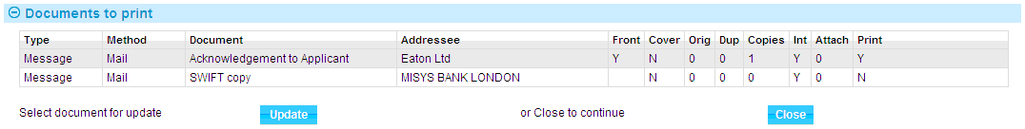

In the window that is then displayed set the documents to be printed in the usual way, then press Close.

## Limits on Assigning Transactions to Teams

When your bank is setting up teams, it can enter a figure to control the maximum number of transactions with work in progress that can be assigned to a team. When this maximum figure is reached, Trade Innovation issues warning messages. Warning messages are produced:

* When a user attempts to save a transaction that, when routed to the appropriate team, would cause that team’s limit to be breached
* When an incoming electronic message is automatically routed to a team, and causes that team’s limit to be breached

In the above cases, the warning message is displayed at the top of the input window when the transaction is saved and when it is opened.

A warning message is also produced if you attempt to allocate a transaction to another team or user if the allocation would cause a breach of limits.

# Graphs and Charts

This chapter explains what the graphs and charts in the Dashboard window show.

## The Overall Totals Pane

The Overall Totals pane shows information in graphical format on the workload for your current team and sub-teams.

The first pie chart (illustrated below) shows how many transactions are allocated to your current team and sub-teams, and how many of them there are at high (Red) status, at medium (Amber) status and at low (Green) status.

All transaction steps – RAG status

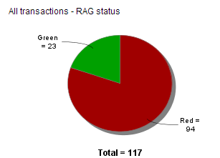

The second pie chart (illustrated below) shows how many transactions there are at each step phase, showing the number of transactions at steps in the data capture, verification or post release phases.

All transaction steps – Input status

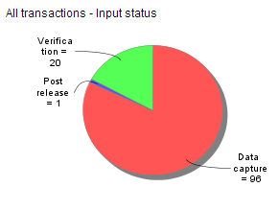

## The Team and User Totals Pane

The Team and User Totals pane uses two different displays to show information about the workloads allocated to the teams to which you belong.

The charts show the number of transactions allocated to the currently selected team and all teams immediately below it in the hierarchy.

The Transactions By field allows you to display data in these charts by:

* Product
* Phase
* Step
* Customer
* Key customer
* Branch
* Team
* User

### By Product

When broken down by product the charts show the number of outstanding transactions, and how many of them there are at high status, at medium status and at low status.

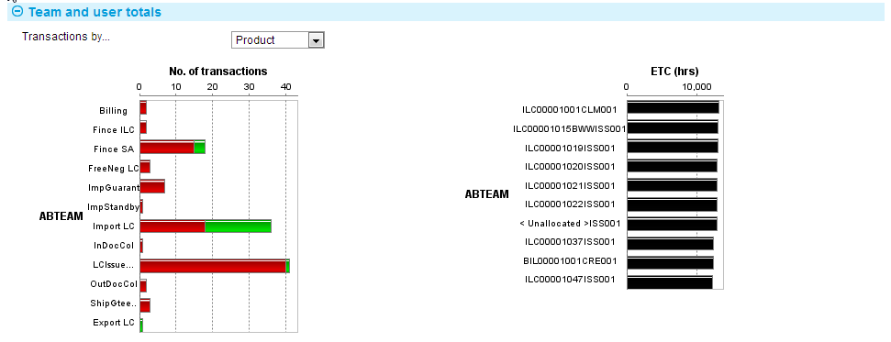

A separate chart is provided for each team. If your bank has hierarchical teams, the data shown in parent teams is for the parent team itself and all the child teams below it.

### By Phase

When broken down by the phase the transaction is in, the chart shows a breakdown of the transactions grouped by the phase of the current step.

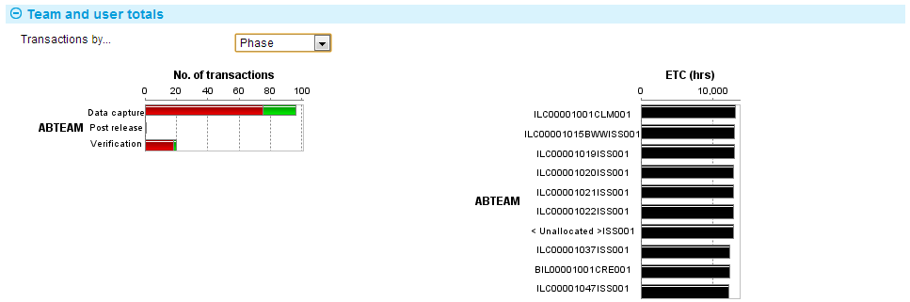

### By Step

When broken down by step, the charts show how many transactions there are at each step in the life-cycle of a transaction.

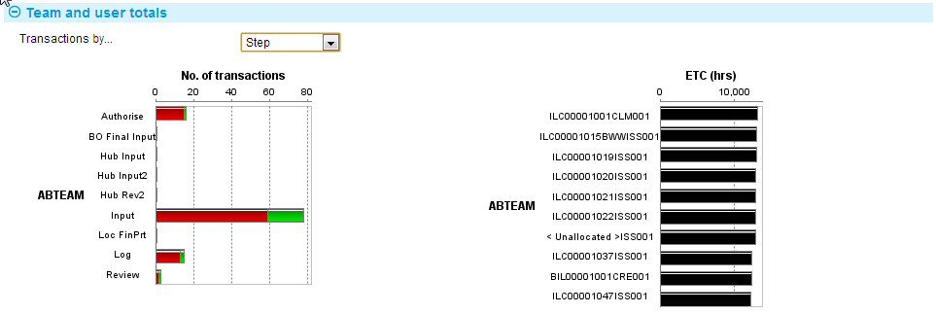

### By Customer or Key Customer

When setting up teams for use with the Dashboard, your bank can identify specific customers as being of more than usual relevance to a particular team. These are termed that team’s ‘key customers’. During transaction processing, the Dashboard can be used to show information for all customers with transactions assigned to your team; or only for your key customers.

When broken down by customer, the charts show how many transactions there are outstanding for all customers with work outstanding.

When broken down by key customer, the charts show how many transactions there are outstanding for the key customers with work outstanding for each of the teams to which you belong.

The same information is shown for customers and key customers.

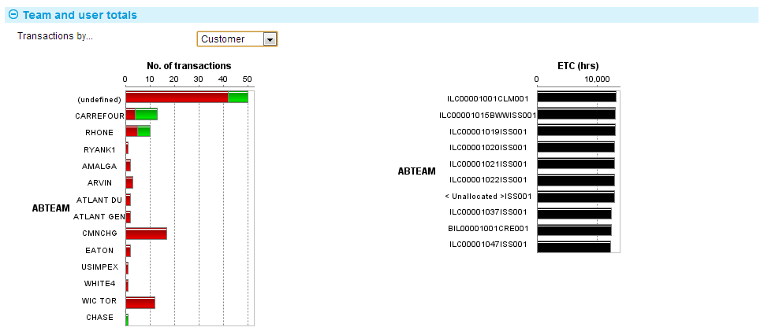

For instructions on defining key customers for a team see the System Tailoring User Guide– Trade Innovation.

### By Branch

When broken down by branch, the charts show transactions by their on behalf of branch.

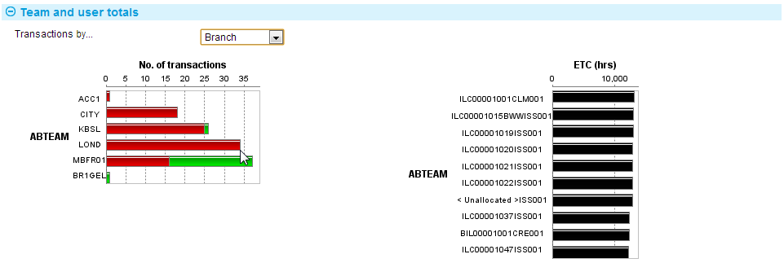

The ETC (estimated time to completion) charts, illustrated above, show the statuses of the most urgent transactions for each team due to complete in the period in question. The period in question is measured from now until the latest target completion time for transactions included in this display, and is shown in hours. You can define the number of transactions to be included in this display - see Chapter 3 (see page 14).

The display indicate the points at which each transaction’s SLA status will change from low to medium, and then to high. Overdue transactions are displayed in black.

### By Team

This option is only available when the currently selected Team has further teams below it. It shows all outstanding work by team and sub-team and how many of them there are at high status, at medium status and at low status.

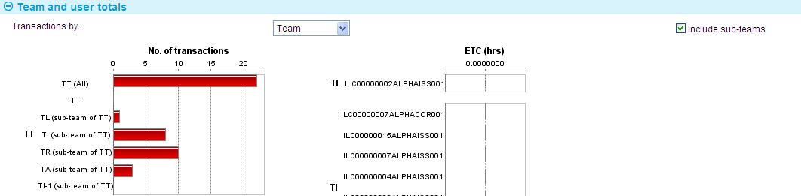

A separate chart is provided for each team. If your bank has hierarchical teams, the data shown in parent teams is for the parent team itself and all the child teams below it.

Un-checking the Include sub-teams check box allows you to only include details from the next level in the hierarchy.

### By User

This option is only available when at the lowest level in the team hierarchy and allows you to view all work assigned to the different users in the team. It shows all outstanding work by user and how many of them there are at high status, at medium status and at low status.

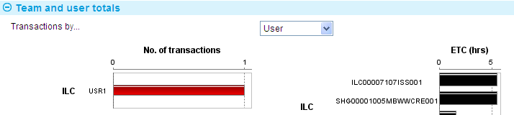

# Appendix Setting Working Profiles

The following table lists the filter fields used in working profiles and explains what each of them controls.

If you change the value in the Product, Business Area, Product Type or Event fields press the Refresh button to update the values in the related drop-down fields.

|  |  |
| --- | --- |
| Field | What it Determines |
| Behalf of Branch | The behalf of branch for the transaction as entered by the user or set from the incoming SWIFT or gateway message. The behalf of branch determines the parameter sets that are to be used to generate charges, documents, postings, etc. during transaction processing. The branch can be changed to any other branch within the same main banking entity that shares the same parameter sets. |
| Responsible Team | Shows transactions where the master is associated with a particular team, or for all teams. |
| Assigned Team | Shows transactions where the event is associated with a particular team, or for all teams. |
| Team | Shows transactions belonging to a particular team, or for all teams. You can only select a team other than your current team if you are assigned to that team. |
| Business Area | Shows transactions associated with the business area that includes the product(s) you wish to work with. |
| Product | Shows transactions for all products or for a particular product only. If you have specified a business area in the Business Area field, then the product field will include products in that business area only. |
| Product Type | Used if you have selected a value in the Product field, to show transactions for all product types within the selected product, or for a particular product type only. If you have not selected a value in the Product field, this field is not available. |
| Event | Shows transactions of that particular event. You cannot specify an event unless you have specified a product. |
| Event step type | This filter allows all steps of a selected type to be shown. For example all log steps. |
| Event step | This filter allows any of the actual step descriptions mapped by your bank to be selected. |
| Master Status | Shows transactions associated with a master of a specific status, or all master records. |
| Step Status | Shows transactions with a specific status. |
| RAG Status | Shows transactions with a high (Red), medium (Amber) or low (Green) status. |
| Customer | Shows transactions for one customer only, or for all customers. If you specify a customer, the system matches that customer against either the principal party or the other party in the master record. |
| Currency | Shows transactions using a particular currency, or all currencies. |
| Amount | Shows transactions with amounts within a certain range. Enter values to define the range either side of the hyphen. |
| Watch List Check - User Action | Limits the display to events with the selected watch list checking user action. See the Common Facilities User Guide – Trade Innovation for a list of values. |